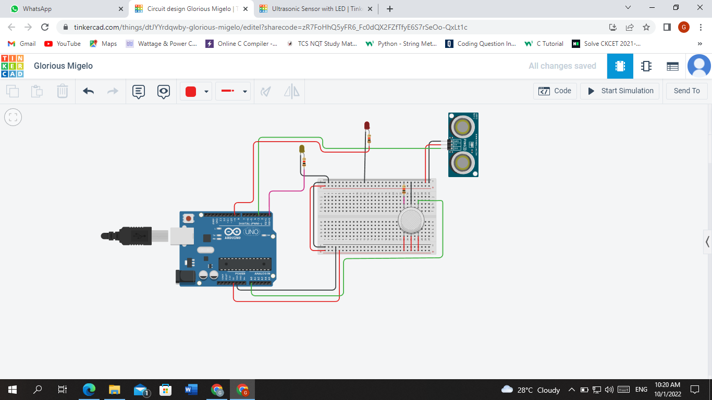

CODE
int LED = A1;
const int gas = 0;
int MQ2pin = A0;

void setup() {
Serial.begin(9600);
pinMode(0,OUTPUT);

}

void loop() {
float sensorValue,MQ2pin;
sensorValue = analogRead(MQ2pin); // read analog input pin 0

if(sensorValue >= 470){
digitalWrite(0,LOW);
Serial.print(sensorValue);
Serial.println(" |SMOKE DETECTED");

}
else{
digitalWrite(0,HIGH);
Serial.println("Sensor Value: ");
Serial.println(sensorValue);
}
delay(1000);
}
float getsensorValue(int pin){
return (analogRead(pin));
}
USE CASES
- Arduino UNO
- Ultrasonic Sensor
- Gas Sensor
- LED

